**Department of Computer Science and Engineering**

Report on Mini Project

Meridian

#### Course Code : 20CS506

#### Course Name : Database Management System

#### Database Management Systems

##### Semester:V SEM Section:C

**Submitted To:**

## Ms. Vaishali Bangera

## Asst. Prof. Gd-1

## Department of Computer Science and Engineering

**Submitted By:**

Muhammed Ismail Naaz (4NM20CS111)

P Aneeshram Bhat (4NM20CS124)

**Date of submission:**

10-12-22

#### Signature of Course Instructor

# ABSTRACT

The Art of Event Management: Creating Memorable Experiences for Every Occasion

Our event management company specializes in creating unique and personalized events that leave a lasting impression on guests. From intimate gatherings to large-scale productions, our team of experienced professionals will handle every aspect of the planning process, ensuring that every detail is executed flawlessly. Whether you are looking to host a corporate conference, a wedding, or a charity fundraiser, we have the expertise and resources to make your event a success. Let us take the stress out of event planning and help you create unforgettable experiences for your guests.

What differentiates us from our competitors is that we really listen to our clients, creating distinctive events tailored to their specific needs and desires. Our innovative mix of solutions ensures that every detail is covered. Get in touch to learn how we can make your dream event a reality.

Experience a seamless and stress-free event with our expert team at Meridian. From conception to execution, we handle every detail to ensure your event is a success.

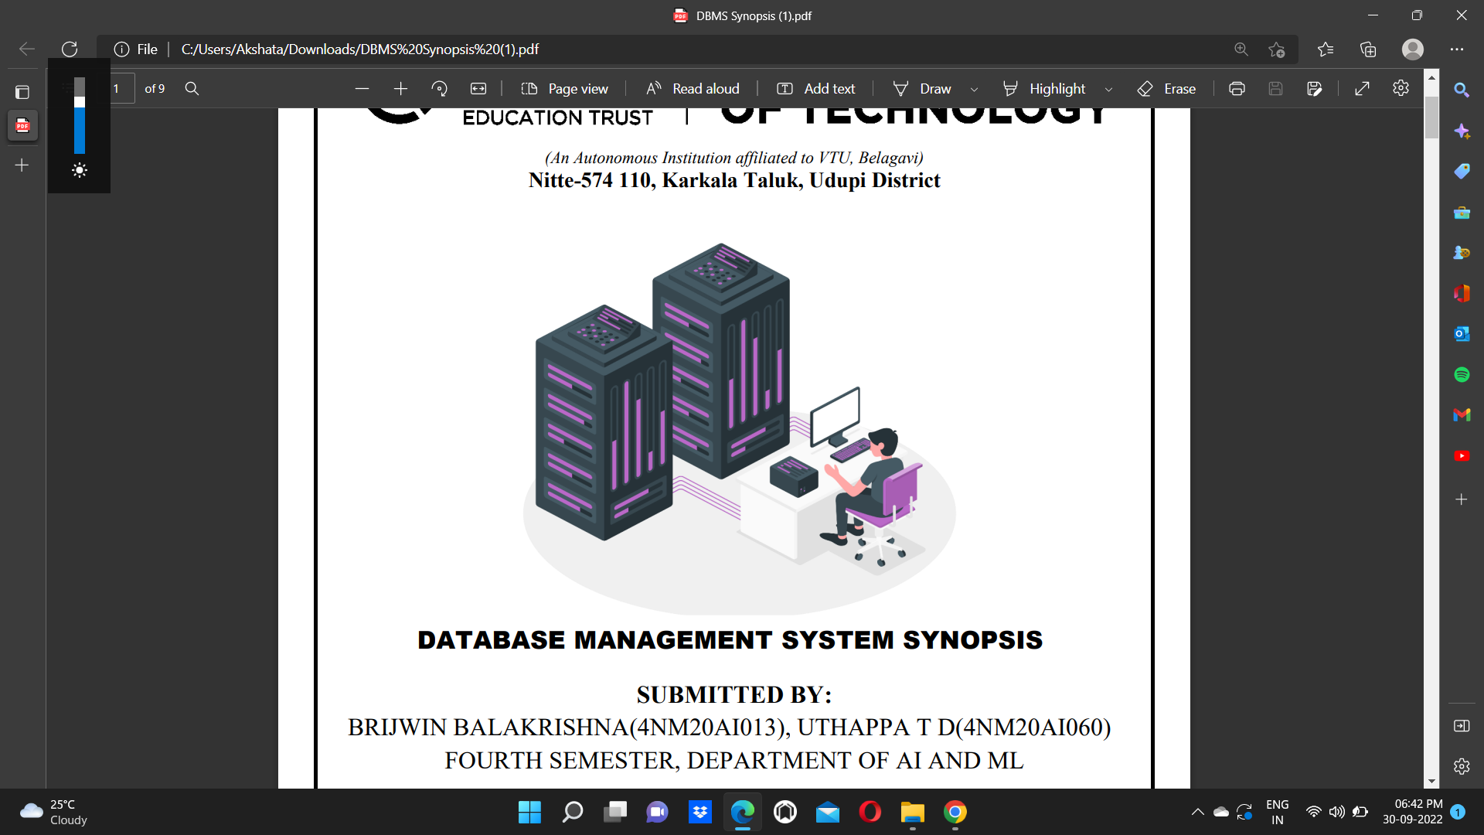At Meridian, we believe in creating unique moments that leave a lasting impression. What differentiates us from our competitors is that we really listen to our clients, creating distinctive events tailored to their specific needs and desires. Our innovative mix of solutions ensures that every detail

# TABLE OF CONTENTS

**Title Page 1**

**Abstract 2**

**Table of Contents 3**

**Introduction** **4**

**Problem Statement** **5**

**Objectives** **6**

**Hardware/Software Requirement** **7**

**Methodology** **8**

**Implementation Details** **10**

**Results 12**

**Conclusion and Future Scope** **16**

**References** **17**

# INTRODUCTION

Event management is a process of organizing a professional and focused event, for a particular target audience. It involves visualizing concepts, planning, budgeting, organizing and executing events such as fashion shows, musical concerts, corporate seminars, exhibitions, wedding celebrations, theme parties, product launching etc.

Event Management is a multi-million dollar industry, growing rapidly, with mega shows and events hosted regularly. Surprisingly, there is no formalized research conducted to access the growth of this industry. The industry includes fields such as the MICE (Meetings, Incentives and Events), exhibitions, conferences and seminars as well as live music and sporting events.

On the profession side, event management is a glamorous and exciting profession that demands a lot of hard work and dynamism.

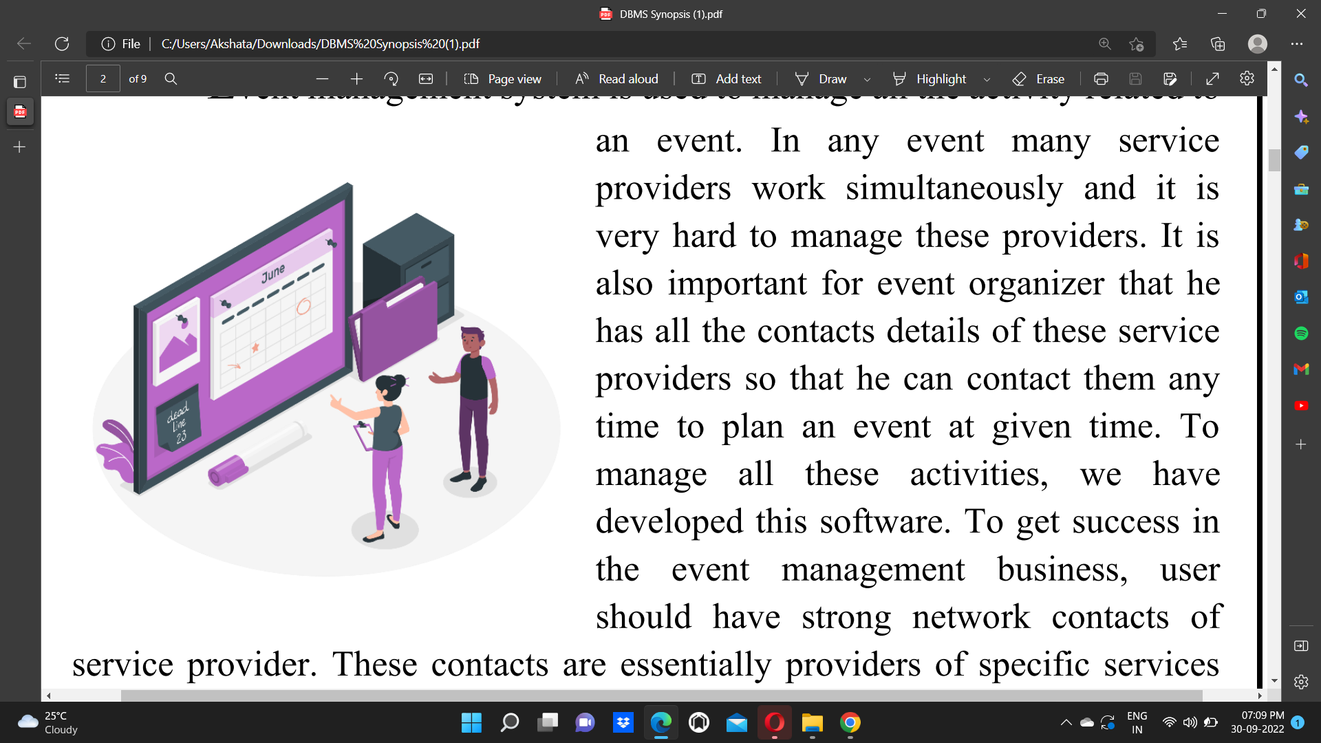The logistics side of the industry is paid less than the sales/sponsorship side, though some may say that these are two different industries.

# PROBLEM STATEMENT

Currently Event Management system is manual and only accessible to staff. The client has to travel to the company offices in order to schedule, book and organize an event such as Birthday Party, Marriage, Reception, Ring Ceremony. Clients pay cash to book for an event which is inconveniencing when customers are many at the company. It takes lots of time of customer because they have to search such event organizer and contact them individually so an online event management system is needed which will enable the customer make booking, schedule events online.



# OBJECTIVES

The objective of event management is to plan and execute successful events that meet the needs and goals of the client. This can involve coordinating various aspects of the event, such as:

* venue selection
* catering
* entertainment
* logistics

The goal is to create a seamless and enjoyable experience for the guests, while also meeting the objectives of the event, such as generating revenue or building brand awareness. Event managers may also be responsible for managing budgets, contracts, and vendors to ensure that the event is successful and within budget.



# HARDWARE / SOFTWARE Requirements

# Software Requirements:

# • IDE: Visual Studio Code Editor

# • Client-Side Technologies: HTML, CSS, Bootstrap

# • Database Server: MySQL, PHP

# • Operating System: Windows/Linux

# Hardware Requirements:

# • Processor: Pentium-3 or Higher

# • RAM: 64MB or Higher

# • Hard Disk: 80GB or Higher



# 

# METHODOLOGY:

# Algorithm

# 

# Table creation

# 

# 

# 

**LANDING PAGE:**

The landing page consists of a navigation bar and images of our past event as bootstrap carousel

**REGISTRATION PAGE:**

In this page you can register to our website or if you already have registered before then you can login into your account

# 

**BOOKING PAGE:**

The booking page will enable you to book any type of event from our website. You can choose the preferable date, provide the estimate guest count and tell us about your budget.

Once you book a event we will contact the user and confirm the booking.

**TESTIMONIAL PAGE:**

In this page you can check the review of our verified users and give us a review of your experience.

# PORTFOLIO PAGE:

At this page you can watch all the images and videos of our past event.

# IMPLEMENTATION

**Development environment:**

* Visual studio code
* XAMPP Distribution
* MySQL

1. **FRONT-END:**

* HTML: HTML stands for Hypertext Markup Language. It is used to design web pages using a markup language.
* CSS**:** CSS is the language we use to style an HTML document. It describes how HTML elements should be displayed.
* Javascript: Javascript is used by programmers across the world to create dynamic and interactive web content like applications and browsers. JavaScript is so popular that it's the most used programming language in the world, used as a client-side programming language by 97.0% of all websites.
* Bootstrap: Bootstrap is a free and open-source CSS framework directed at responsive, mobile-first front-end web development. It contains HTML, CSS and JavaScript-based design templates for typography, forms, buttons, navigation, and other interface components.

1. **BACK-END:**

* PHP**:** The term PHP is an acronym for Hypertext Pre-processor. PHP is a server-side scripting language designed specifically for web development. The files have the extension “.php”.
* Xampp Server: XAMPP is a free and open-source cross-platform web server solution stack package developed by Apache Friends, consisting mainly of the Apache HTTP Server, MariaDB database, and interpreters for scripts written in the PHP and Perl programming languages.
* phpMyadmin: phpMyAdmin is a free and open source administration tool for MySQL and MariaDB. As a portable web application written primarily in PHP, it has become one of the most popular MySQL administration tools, especially for web hosting services.

**ER DIAGRAM:**



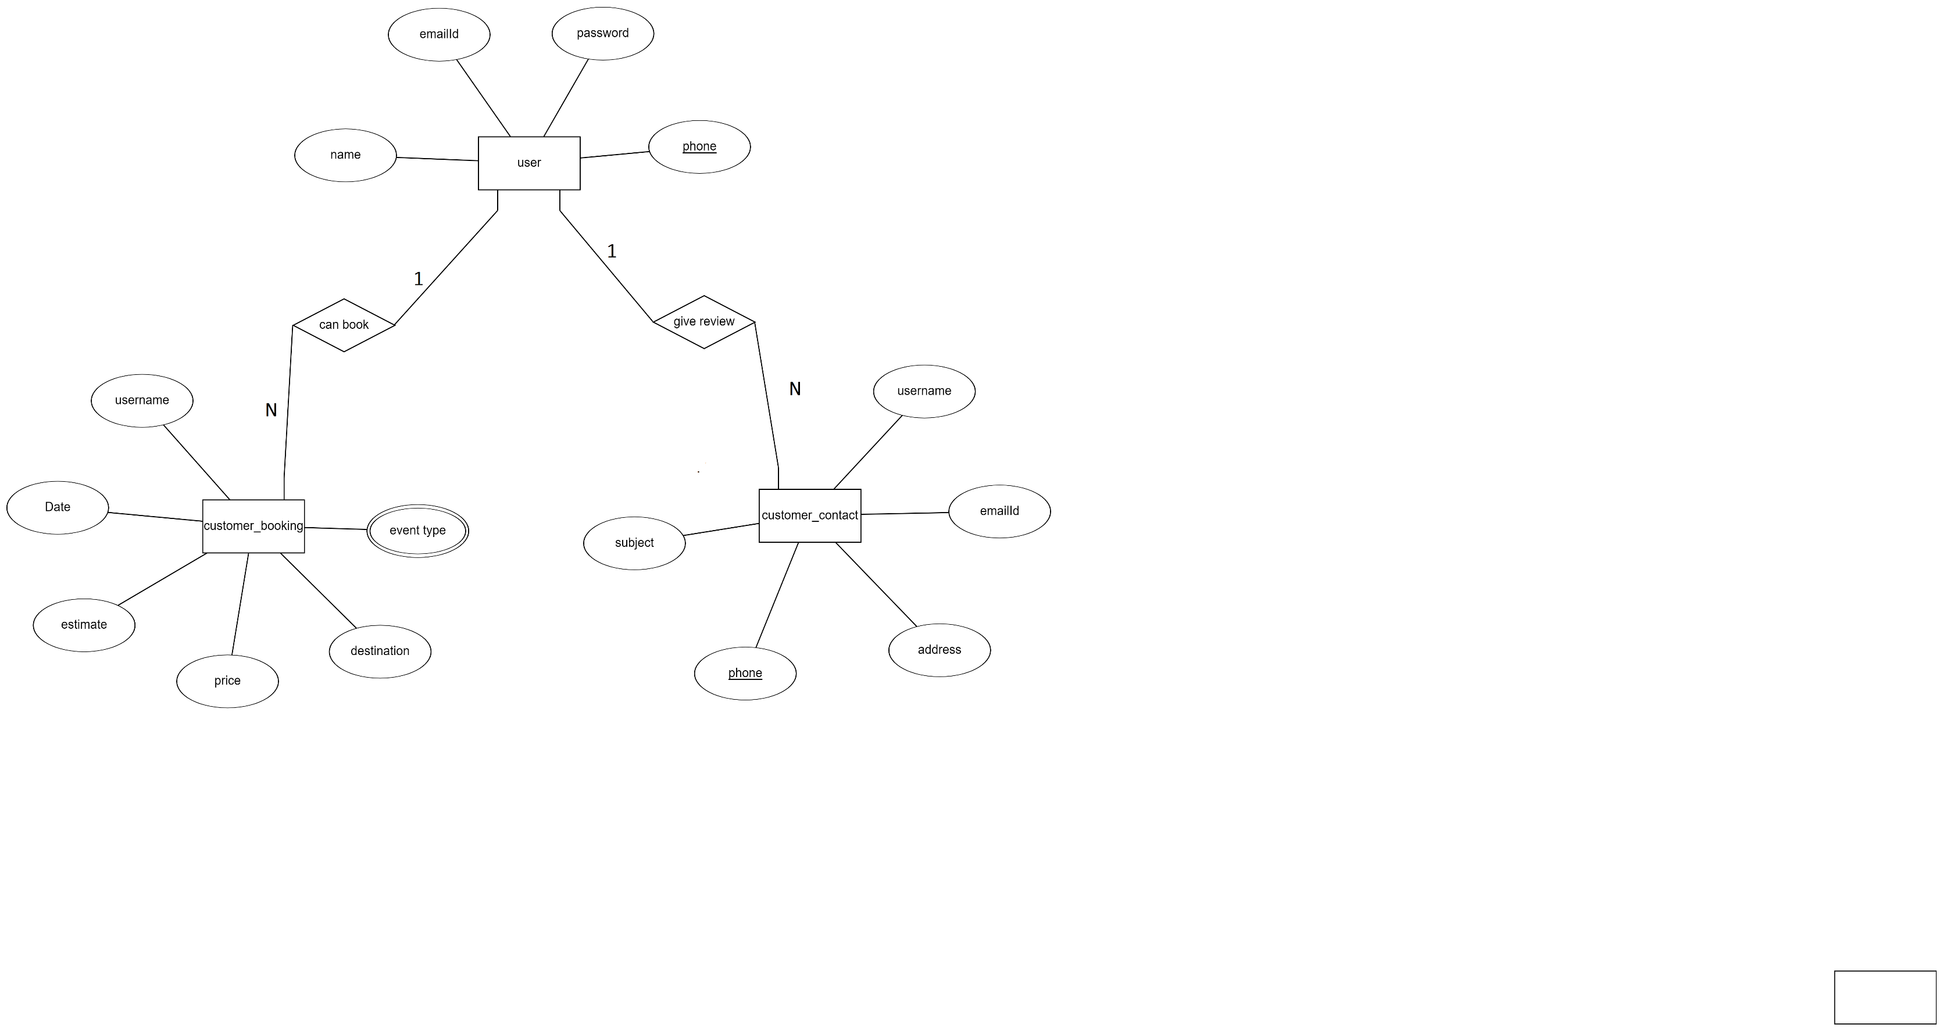

**Relational Schema:**

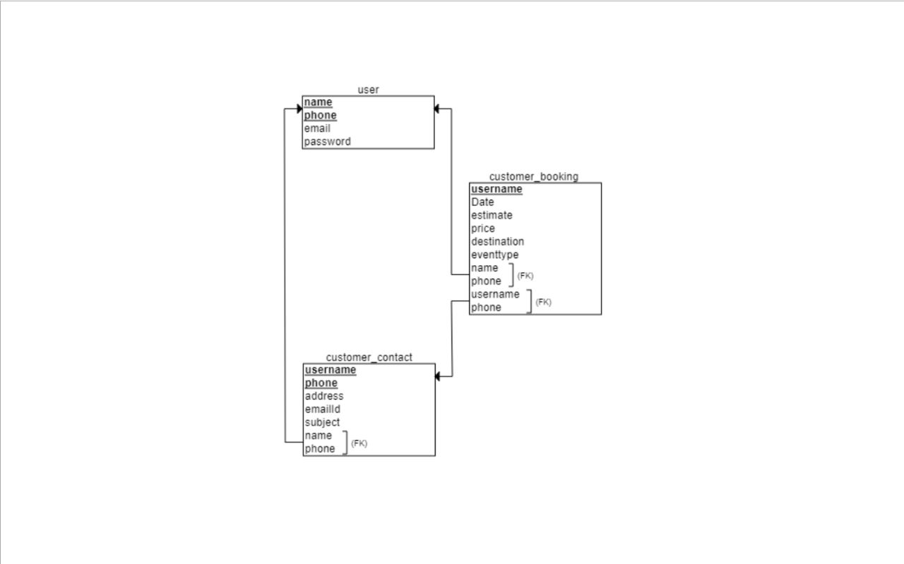

**RESULTS AND DISCUSSIONS**

**LANDING PAGE:**

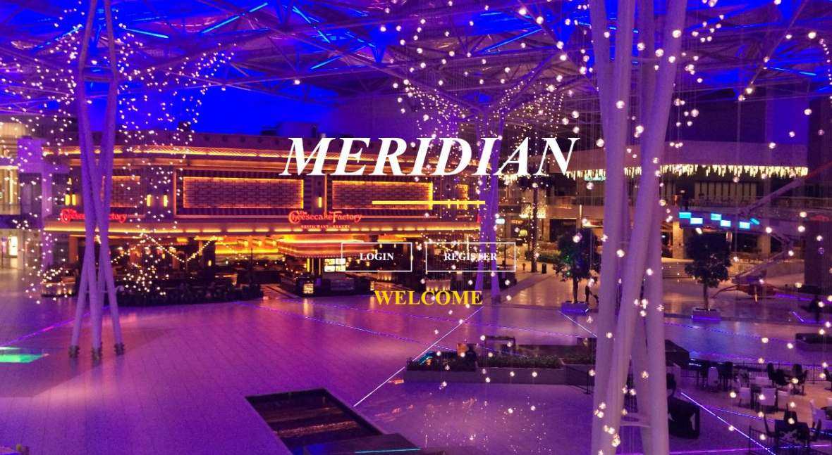

**REGISTRATION PAGE:**

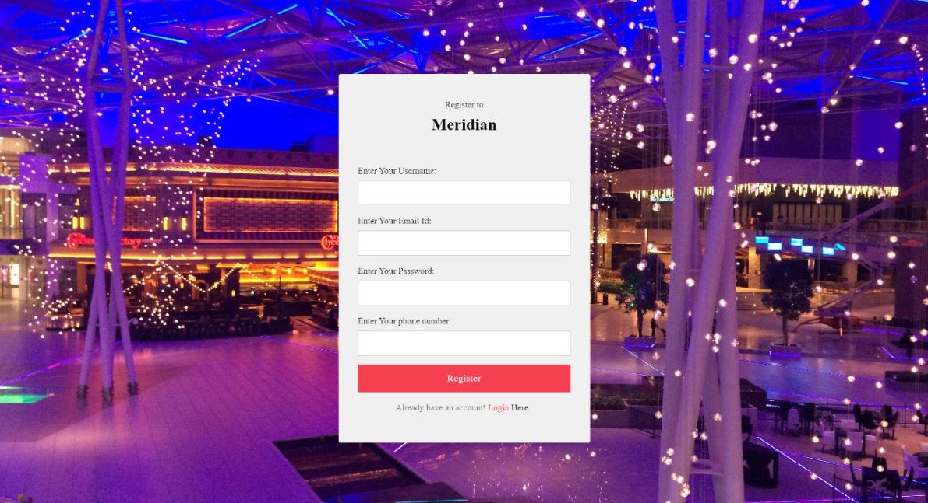

**BOOKING PAGE:**

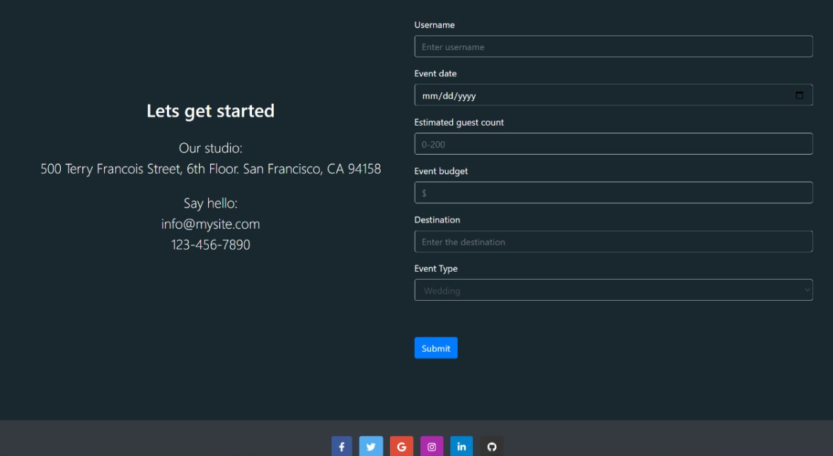

**TESTIMONIAL PAGE:**

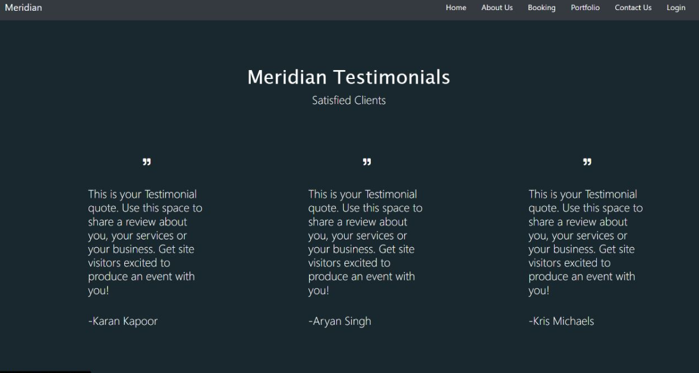

# PORTFOLIO PAGE:

# 

# QUERIES:

# SELECT C.estimate as No_Of_People, B.emailId as Email_ID FROM customer_contact B, customer_booking C WHERE C.username=B.username GROUP BY estimate HAVING estimate<200;

# 

# SELECT MAX(price)

# FROM customer_booking

# 

# SELECT price

# FROM `customer_booking`

# ORDERBY estimate

# 

# SELECT c.phone as PHONE, b.price as PRICE FROM customer_contact c, customer_booking b WHERE c.username=b.username AND emailId="aneeshram19@gmail.com";

# 

# CONCLUSION AND FUTURE SCOPE

Event Management System is user friendly and cost effective system, it is customized with activities related to event management life-cycle. It provides a new edge to management industry. **Meridian** always keep your objectives and goals on top priority while developing any plan of work.

Currently the site doesn’t have third party associations with any catering services .

The future scope of the site would be giving an option to choose the catering services.

We would also want to add the hall booking option so that the entire process of the event from the food to the hall is taken care in just few seconds with **Meridian.**

# REFERENCES

➢ <https://www.w3schools.com/css/>

➢ <https://www.w3schools.com/html/>

➢ <https://www.tutorialspoint.com/php/index.htm>

➢ <https://www.w3schools.com/bootstrap/>

➢ <https://github.com/>

➢ <https://www.projectmanager.com/training/how-to-plan-an-event>